Datatypes and Format Specifiers Assignment

1. WAP to read the following information at run time and to display. Choose appropriate data type and format specifier.
- username [maximum of length 125]
- age
- Salary [float]
- Designation code [as short type with values {1, 2, 3, 4, 5, 6}
- Gender [a single char field]
- Code:
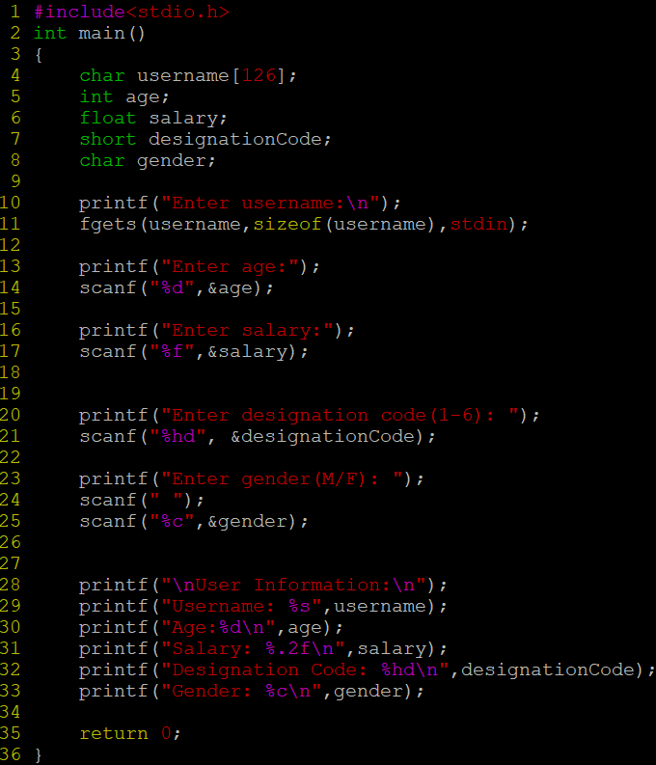

Output:
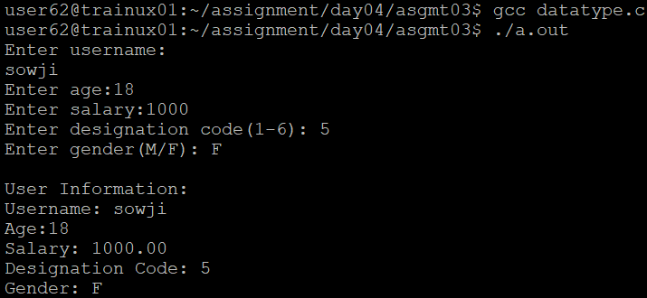
2. WAP to read a user choice as ‘y’ or ‘Y’ or ‘n’ or ‘N’ and display read choice as “Yes” or “No”
according to the input received.
‘y’ or ‘Y’→ display “Yes”
‘n’ or ‘N’→ display “No”
for any other character received → display “invalid character” and exit
- Code:
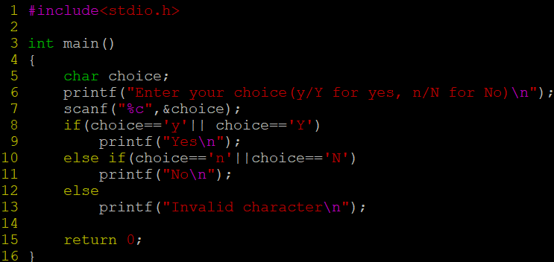
Output:
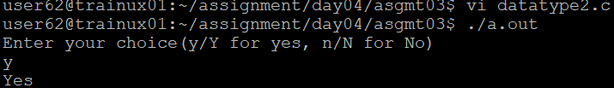

3. WAP to read a number in decimal (0-127) and display it in 2-digit hex character.
A. Code:
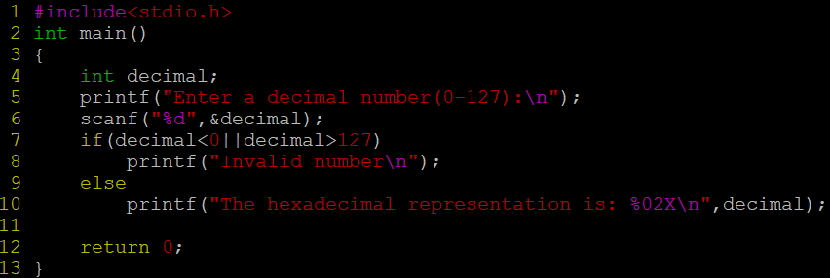
Output:
